INSTRUCTIONS MANUAL
ıce – cream conservators ENGLISH
ENGLISH

301006-0905

1. GENERAL INFORMATION
1.1 FOREWORD
1.2 DESTINATION OF USE AND RESTRICTIONS
1.3 TESTING
1.4 INFORMATION FOR YOUR SECURITY
1.5 RESPONSIBILITY OF THE CUSTOMER
2.0 TECHNICAL FEATURES
2.1 MATERIALS AND FLUIDS
2.2 SAFETY MECHANICAL CHARACTERISTICS, RISKS.
3. INSTALLATION
3.1 REMOVAL OF THE PACKAGE
3.2 POSITIONING
3.3 ELECTRICAL CONNECTION
4. OPERATION
4.1 TEMPERATURE SETTING
4.2 DEFROSTING
5. PERIODICAL MAINTENANCE
5.1 PRECAUTIONS FOR THE MAINTENANCE
5.2 CLEANING THE APPLIANCE AND THE ACCESSORIES
5.3 LONG INACTIVITY PRECAUTIONS
6. EXTRAORDINARY MAINTENANCE OPERATIONS
6.1 CLEANING THE CONDENSER
6.2 REPLACING THE LAMPS
6.3 TROUBLE SHOOTING
7. DISPOSAL AND DEMOLITION
7.1 WASTE STORAGE
7.2 PROCEDURES FOR THE DISASSEMBLY OF THE APPLIANCE
8. WARNINGS
9. WIRING DIAGRAMS

1. GENERAL INFORMATION

1.1 FOREWORD
The purpose of this document is to provide important information, regarding the installation, use and maintenance of this appliance.
Before any operation you should read carefully the information contained in this manual.
If your appliance has a lock, keep it locked and store the key in a safe place, out of the reach of children. If you are discarding an appliance with lock, make sure that, is made ineffective. This precaution is very important so as to avoid children being trapped inside, which may cause their loss of life.

The manufacturer declines all responsibility for any operations effected on the appliance without respecting the instructions reported in this manual.

1.2 DESTINATION OF USE AND RESTRICTIONS
The purpose of this appliance is to chill and conserve food stuff. Any other use of the appliance is to be considered improper.
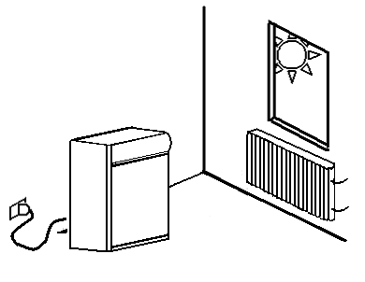
ATTENTIONS: The appliance is not fit for external installations and environments subjected to the actions of atmospheric agents (rain, direct sun light)
The manufacturer declines every responsibility for any improper use of the product.

1.3 TESTING
The appliance is shipped ready for use. The fulfilment of the tests and inspections (visual inspections-electrical test- functional test) is guaranteed and certified.

1.4 INFORMATION FOR YOUR SECURITY
The construction of the appliance is made according to the European security laws 73/23/EEC, the electric wirings according to the EN 60335-2-24 norms.

1.5 RESPONSIBILITY OF THE CUSTOMER
Setup an electrical outlet connected effectively to earth, suitable to provide the voltage indicated on the data plate. Make sure that the machine rests on a levelled surface.

2.0 TECHNICAL FEATURES

2.1 MATERIALS AND FLUIDS
The sections that come into contact with the products are made of galvanized steel, aluminium or non-toxic plastic materials.
A cooling fluid approved by law regulations, HFC, is used in the cooling unit.
The type and quantity of the gas charged in the refrigerant unit is indicated on the data plate.

2.2 SAFETY MECHANICAL CHARACTERISTICS, RISKS.
The cabinet has no sharp edges, profiles, nor projecting parts. The protections for the moving and electric parts are fixed to the appliance with screws, to prevent any accidental access to these dangerous points. This equipment is intended for the storage and display of non-potentially hazardous, bottled or canned products only.

2.3 CHEST ICE-CREAM CONSERVATORS TECHNICAL FEATURES

Specifications are subject to change without notice.
2.4 UPRIGHT ICE-CREAM CONSERVATORS TECHNICAL FEATURES

Specifications are subject to change without notice.

3. INSTALLATION
In order for the appliance to work correctly, and to maintain the safety conditions during performance, follow the manufacturer’s instructions reported in this chapter.

3.1 REMOVAL OF THE PACKAGE
Before proceeding to unpack the appliance, check the packing of the cooler and its protections.
Any damage should be reported immediately to the carrier.
Under no circumstances any damaged appliance can be returned to the manufacturer without prior written authorization. Remove the polythene, paying attention not to scratch the sides with sharp blades or scissors.
Remove all protections.
Use a fork-lift to lift the appliance and take it to the place of installation; make sure that the load is balanced.
The components of packing should be disposed according to the local law.
Some components of the packing are marked as recyclable to allow their identification.
ATTENTION: During installation, do not push or drag the appliance to avoid that it capsizes.

3.2 POSITIONING
The appliance must be placed in an adequately ventilated room as far as possible from heat sources, such as radiators or conditioning pipes, to allow free air circulation to the refrigerator unit. The environment temperature must not be higher than the values which shown in the technical features tables.
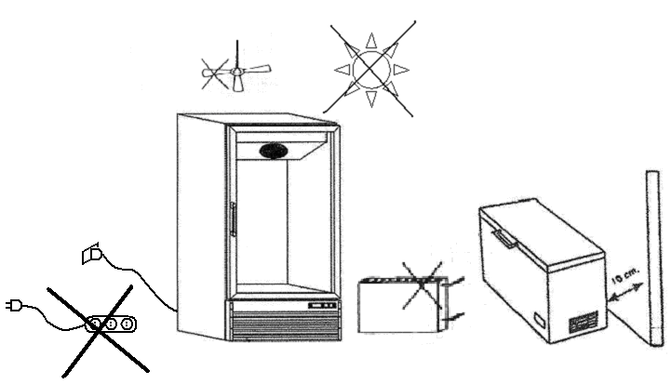
Appliance must have a clearance of 125mm at top, 100mm at the rear and 25mm at each side.
In case of CNV 50 and CNV 100 to be hanged from a wall, the wall should be strong (concrete or likewise) enough to support it.
Adjust the height of the appliance and level it by rotating the adjustable feet, remembering to check that the door opens and closes freely.

3.3 ELECTRICAL CONNECTION
WARNING: DO NOT USE EXTENSION CORDS
The cooler works on single phase voltage (230V 50Hz or 115V 60Hz) power supply.
Power supply line must be equipped with 15A fuse.
To switch on the appliance, insert the plug into the mains socket,
WARNING!
* The mains socket must be easy-accessible. The mains socket is provided with an efficient ground, the voltage and frequency of the electric line matches with those indicated on the data plate. In case of doubts about the efficiency of the ground, have your electric line checked by a qualified technician.
* When the appliance is performing, check that the supply voltage isn't dropping or increasing under / over + 6% the rated voltage.

The manufacturer declines any responsibility for possible damages or accidents arising from the violation of the rules above exposed or of the safety electric laws relevant the country of use of the appliance.

4. OPERATION
1. Plug in the appliance one hour after the installation.
2. Make sure that the green light, located on the control panel, be alight
3. Before locating foods in the appliance, set the thermostat knob on position no.3.

When starting, the noise of the compressor might be quite high but it will progressively decrease after a necessary running in.
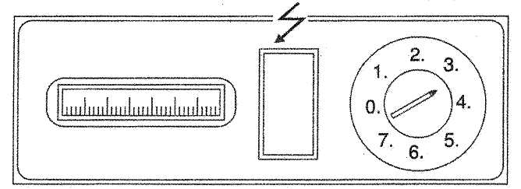

WARNING: Never load chest freezer above maximum load line indication.

4.1 TEMPERATURE SETTING
The inner temperature of appliances is automatically kept at -18˚C by a thermostat to be set on the control panel.
This device is directly set by the manufacturer to work at normal ambient temperature.
The setting of the internal temperature must consider several facts such as:
Ambient temperature, the frequency of door opening, the quantity of food stored to be refrigerated or frozen.
Never load chest freezer above maximum load line indication. The period of the storage temperatures. Changes in storage temperature will have repcussions on the time of
storage. In case of power failure, do not open the lid. The stored products will be maintained at freezing state for 6-12 hours. However they must be used within one month. For longer power failures wrap frozen products in newspaper and place them in a refrigerator or in a cool location.
Note: The temperature settings and defrost settings of the no frost models are checked by the electronic control units.

4.2 DEFROSTING
It is necessary to proceed to this operation any time that has reached a thickness of 2-3 mm (frost which is formed by the condensation of moisture in the air acts as insulation, therefore reducing appliance performance).

Proceed as follows:
24 hours before defrost, set thermostat knob to the coldest position or switch on the fast freeze switch to bring products to the coldest temperature.
Wrap frozen products in newspaper, placing them in a refrigerator or cool room. Disconnect plug from socket.
Leave lid open.
To speed up the proceeds, to you may scrape appliance walls a plastic scraper. Never use sharp metal objects or heaters.
When defrost is complete, clean and dry interior. Reintroduce frozen products. Close lid. Connect plug into socket. Let appliance run 3-4 hours with thermostat on coldest setting or with fast freezer switch on.

IMPORTANT: Some chest freezers have a water drain which allows an easier defrost operation. Usually this drain is to be found on the lower section of the back wall and it is closed by an “I” shaped plug. During defrost this plug may be removed. It can be rotated and its tubular section reinserted in the hole. This way water will flow out and can be more easily collected in a shallow pan. Once defrost is completed, reinsert plug in its original position.

5. PERIODICAL MAINTENANCE

5.1 PRECAUTIONS FOR THE MAINTENANCE
The ordinary maintenance operations can be performed by not specialized personnel, only if carefully following the instructions reported in this chapter.
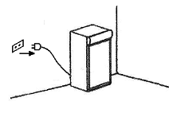
ATTENTION: Before carrying out any cleaning or maintenance operations, disconnect the appliance from the supply at the mains. Do not remove the safety devices (grates, guards, earthlings, etc.)

5.2 CLEANING THE APPLIANCE AND THE ACCESSORIES
Before use and periodically, clean the cooler and all accessories of the appliance with warm water and neutral soap rinse with clean water and wipe dry.
Do not use detergents such as solvents or abrasive powders.

5.3 LONG INACTIVITY PRECAUTIONS
If the appliance is not going to be used for a long period, then these instructions must be followed:
* Disconnect the plug from mains socket.
* Remove all the products and clean the cell and accessories.
* Leave the doors open in order to allow air circulation in the cell, this is to prevent the formation of mould and bed smells.
* Make sure that premises are aired regularly.

6. EXTRAORDINARY MAINTENANCE OPERATIONS
The extraordinary maintenance operations must be carried out by specialized personnel only.

6.1 CLEANING THE CONDENSER
The cleaning of the appliance depends on the use of the machine.
ATTENTION: The periodic cleaning of the condenser is necessary to guarantee a good performance and function of the appliance in time. We advise cleaning the fins of the condenser: once a month in a dusty environment. To remove the dirt, use a brush or a vacuum cleaner. Do not use pointed objects as these could damage the condenser.
Caution! Do not wash the appliance with direct or high pressure water jets.
Note: For model NV450NF exactly the same cleaning instructions are also valid for its evaporator assembly.

6.2 REPLACING THE LAMPS
* Disconnect the plug from mains socket.
* Unscrew and remove the canopy side plastics.
* Take the canopy sticker plastic out.
* Take the lamp out from the lamp holders.
* Detach the lamp from the sockets.
* Attach the lamp to the sockets.
* Insert the lamp to the lamp holders.
* Install the canopy sticker plastic.
* Locate and screw the canopy side plastics.
* Plug the appliance in.

6.3 TROUBLE SHOOTING
Often the faults that occur during performance are caused by banal mistakes nearly all resolvable without the assistance of a specialized technician, therefore before to get in touch with a technical assistance centre, verify how much follows:
a) The appliance does not start:
Check that the plug is correctly inserted into the socket.
Verify that there is voltage at the socket.
b) The cell is too hot:
Check the regulation of the thermostat.
Check the perfect closing of the doors.
c) The appliance is excessively noisy:
Verify the level of the appliance. A not levelled appliance could cause some vibrations.
Check that the cooler is not touching other coolers or other parts that could enter in resonance.
Carry out this Check up and if the fault persists, get in contact with our technical assistance centres. Remember to signal:
- The type of fault: (electrical, mechanical)
- The code and serial number of cooler, that can be found written on the sticker.

7. DISPOSAL AND DEMOLITION

7.1 WASTE STORAGE
Temporary storage of special waste is permitted but only if the final purpose will be the definitive disposal by treatment and/or final collection.
Dispose the special waste according to the law regulations of your country.
Keep the environment clean.

7.2 PROCEDURES FOR THE DISASSEMBLY OF THE APPLIANCE
All countries have different legislations; therefore, the specific prescriptions enforced by the legislation and the local authorities of the country where the cooler is demolished must be observed.
A general rule is to hand over the cooler to specialized collection / demolition centres.
Disassemble the cooler and divide the components separately according to their chemical characteristics. Remember that the compressor contains oil and refrigerant gas which can be recycled.
The coolers components are categorized as special urban waste.

8. WARNINGS
* Keep the ventilation holes in the cabinet free from obstructions.
* Do not use any mechanical or other tool different from the ones recommended by the manufacturer, in order to speed up the defrosting.
* Do not damage the circuit of the refrigerant fluid.
* Do not use any electrical appliance, apart from the ones recommended by the manufacturer, inside the freezing compartment.
* Keep enough space in order to easily reach the main plug.
* If the power cable is damaged, it must be replaced by the manufacturer or by its after sales service, or in any case by a person with similar title, to prevent any possible risk.

THE DISASSEMBLY OPERATIONS MUST BE CARRIED OUT BY QUALIFIED PERSONNEL.

This appliance is marked according to the European directive 2002/96/EC on Waste Electrical and Electronic Equipment (WEEE).

By ensuring this product is disposed of correctly, you will help prevent potential negative consequences for the environment and human health, which could otherwise be caused by inappropriate waste handling of this product.

The symbol on the product indicates that this product may not be treated as household waste. Instead it shall be handed over to the applicable collection point for the recycling of electrical and electronic equipment
Disposal must be carried out in accordance with local environmental regulations for waste disposal.
For more detailed information about treatment, recovery and recycling of this product, please contact your local city office, your household waste disposal service or the shop where you purchased the product.

9. WIRING DIAGRAMS
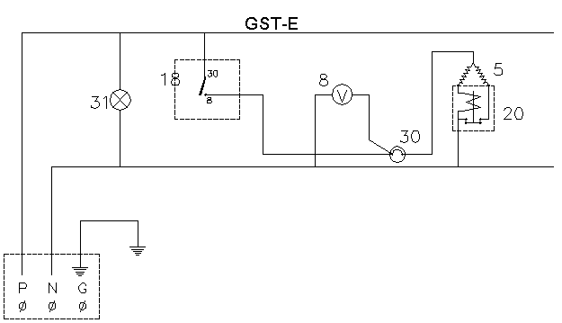
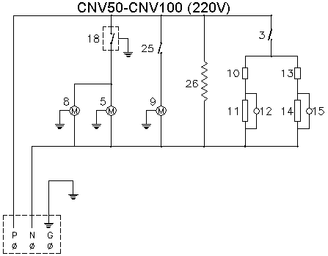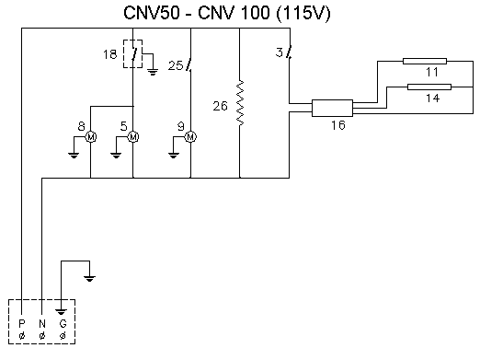

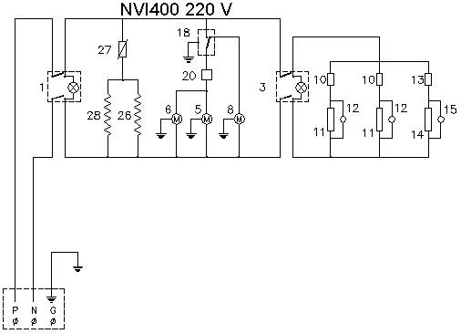

EMBED MSPhotoEd.3 